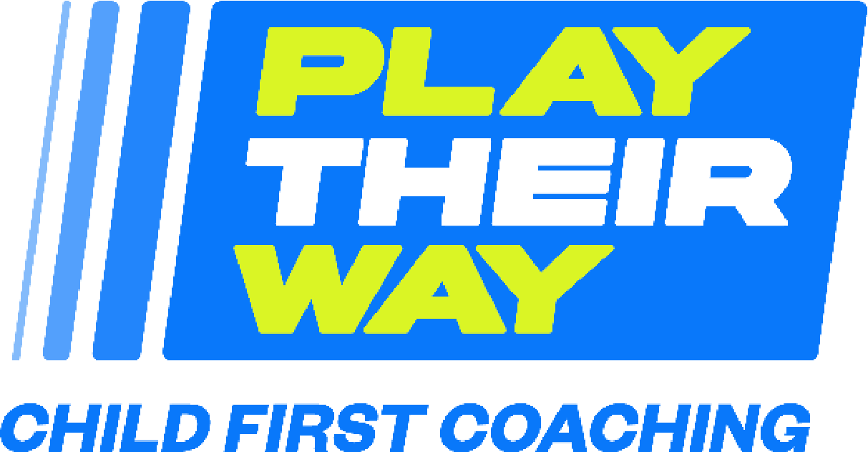

Child-first Champion
Board Champion Role

To embed child-first principles why not appoint a child-first champion to your board? Here is an example of a child-first champion role description.

At board level –support insert organisation in maintaining the Play their Way philosophy.
Drive/ensure the development and implementation of the Play Their Way action plan.
Ensure Play their Way is embedded as appropriate within the work/discussions and decisions of the board.
Promote the importance of developing a culture of listening to young people within and through insert organisation policies, procedures and services.
Provide support, check and challenge to insert organisations CYP lead/s through regular meetings/discussions.
Promote Play their Way at a strategic level to the wider network.

