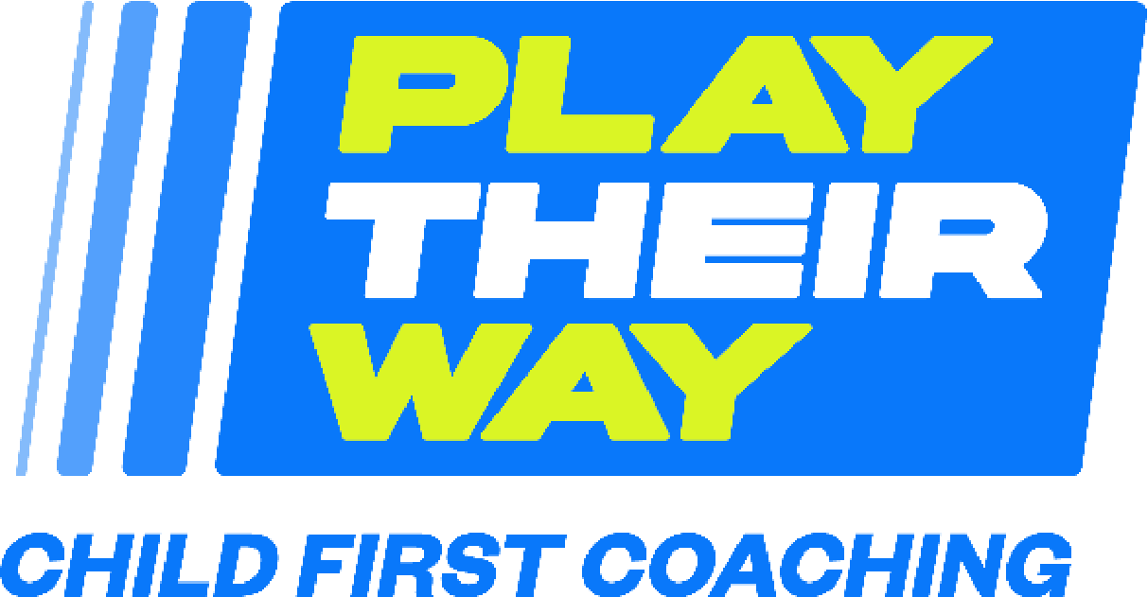

Join The Movement
Public Statement Letter

We are delighted to announce that <insert organisation> has joined the Play Their Way child-first coaching movement.

Child-first coaching is an evidence-informed approach that prioritises the fundamental rights of all children and young people in sport and activity, regardless of their age, gender, background, or ability. There are three key ingredients of this approach which reflect the rights of children and young people to be heard, to play and to develop.

Voice: Children and young people have space to share their views, which are acted on together in a meaningful way.

Choice: Children and young people shape how they play and participate.

Journey: Children and young people can develop holistically, in their own way.

By signing up to this pledge we recognise the role coaches play in enabling children’s enjoyment of physical activity. If they play their way, more children and young people will enjoy being active with the potential to lead happier and healthier lives.

